UCS 2312 Data Structures Lab
Exercise 2: ListADT and its applications
Date of Exercise: 19.09.2023

Create an ADT for the linked list data structure with the following functions. listADT will have the integer array and size. [CO1, K3]
- insert(header,data) – Insert data into the list using inserting at front
- display(header) – Display the elements of the list
- insertAtEnd(header,data) – Insert data at the end of the list
- searchElt(header, key) – return the value if found, otherwise return -1
- findMiddleElt(header) – find the middle element in the list
- reverseList(header) – Reverse the list
- detectLoop(header) – return the status of whether the loop is present or not
- deleteElt(header,data) – Deletes the element data
Write a program in C to test the listADT for its operations with the following test cases.

Operation | Expected Output
length(header) | 0
insert(header,2) | 2
insert(header,4) | 4, 2
insert(header,6) | 6, 4, 2
insert(header,8) | 8, 6, 4, 2
length(header) | 4
insertLast(header,1) | 8, 6, 4, 2, 1
insertLast(header,3) | 8, 6, 4, 2, 1, 3
length(header) | 6
findMiddleElt(header) | 2 or 4
reverseList(header) | 3, 1, 2, 4, 6, 8
searchElt(4) | 4
searchElt(5) | -1
deleteElt(2) | 8, 6, 4, 1, 3

Best practices to be followed:
- Design before coding
- Usage of algorithm notation
- Use of multi-file C program
- Versioning of code

Write a program to subtract the given two polynomials
Example:
Poly1: 6x⁷+8x³ +7x²+9,
Poly2: 7x³+6
Resultant Poly: 6x⁷+15x³+ 7x²+15

DATA STRUCTURE – LINKED LIST

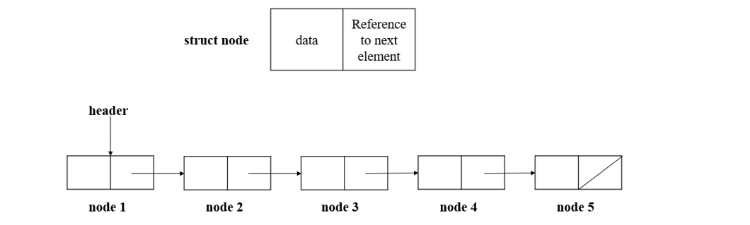

ALGORITHMS:

1.FUNCTION NAME: insert
INPUT:
i)struct node *
ii)ele (int)
OUTPUT: None

- struct node *temp;
- temp=(struct node*)malloc(sizeof(struct node));
- temp->data = ele;
- struct node *ptr;
- ptr = h->next;
- if (ptr==NULL)
{
temp->next = h->next;
h->next = temp;
}
- else
{
temp->next = h->next;
h->next = temp;
}

2.FUNCTION NAME: display
INPUT:
i)struct node *
OUTPUT: None
- struct node *ptr;
- ptr=h->next;
- while(ptr!=NULL)
{
DISPLAY ptr->data
ptr=ptr->next;
}

3.FUNCTION NAME: insertatend
INPUT:
i)struct node *
ii) ele (int)
OUTPUT: None

- struct node *ptr,*prev;
- ptr = h->next;
- while (ptr != NULL)
{
prev = ptr;
ptr = ptr->next;
}
- struct node *temp;
- temp = (struct node *)malloc(sizeof(struct node ));
- temp->data = ele;
- temp->next = prev->next;
- prev->next = temp;

4.FUNCTION NAME: searchElt
INPUT:
i)struct node *
ii)key(int)
OUTPUT: int

- struct node *ptr;
- ptr = h->next;
- while (ptr!=NULL)
{
IF (ptr->data == key)
return key;
ptr=ptr->next;
}
- return -1;

5.FUNCTION NAME: findMiddleElt
INPUT:
i)struct node *

OUTPUT: None

- struct node *ptr;
- ptr = h->next;
- int len = length(h);
- int k=0;
- if (len%2==0)
{
while (ptr !=NULL)
{
k=k+1;
if (k==len/2 || k==len/2+1)
{
DISPLAY ptr->data
}

ptr=ptr->next;

}
}
- else
{
while (ptr !=NULL)
{
k=k+1;
if (k==(len+1)/2)
{
DISPLAY ptr->data
}

ptr=ptr->next;

}
}

6.FUNCTION NAME: reverseList
INPUT:
i)struct node *
OUTPUT:None

- struct node *ptr,*temp;
- ptr = h->next;
- while (ptr->next!=NULL)
{
temp=h->next;
h->next=ptr->next;
ptr->next = (h->next)->next;
(h->next)->next = temp;
}

7.FUNCTION NAME: detectLoop
INPUT:
i)struct node *

OUTPUT: int

- struct node *ptr;
- ptr=h->next;
- struct node *arr[100];
- int i=0;
- while(ptr!=NULL)
{
if (i==0)
{arr[i]=ptr;
i++;
ptr=ptr->next;
}
- else
{
int count = 0;
for (int j=0;j<i;j++)
{
if (ptr==arr[j])
count+=1;

if (count>0)
return 1;
}
i++;
ptr=ptr->next;
}

}
- return 0;

8.FUNCTION NAME: deleteElt
INPUT:
i)struct node*
ii)ele (int)
OUTPUT: None

- struct node *ptr;
- struct node *prev;
- int res = search(h,ele);
- if (res != -1)
{ ptr=h->next;
prev=h->next;
int k =0;
while (ptr!=NULL)
{
if (ptr->data == ele)
{
if (k==0)
{
h->next=ptr->next;
break;
}
else
{
prev->next=ptr->next;
break;
}
}
else
{
k++;
prev=ptr;
ptr=ptr->next;
}
}
}
- else
{
printf("Element doesnt exist!");
}

CODE:
“listadt.h”

#include <stdio.h>
#include <stdlib.h>
struct node
{
int data;
struct node *next;
};

void insertfront(struct node *h,int ele)
{
struct node *temp;
temp=(struct node*)malloc(sizeof(struct node));
temp->data = ele;
struct node *ptr;
ptr = h->next;
if (ptr==NULL)
{
temp->next = h->next;
h->next = temp;
}
else
{
temp->next = h->next;
h->next = temp;
}
}

void display(struct node *h)
{
struct node *ptr;
ptr=h->next;
while(ptr!=NULL)
{
printf("%d ",ptr->data);
ptr=ptr->next;
}
}

void insertAtEnd(struct node *h,int ele)
{
struct node *ptr,*prev;
ptr = h->next;
while (ptr != NULL)
{
prev = ptr;
ptr = ptr->next;
}
struct node *temp;
temp = (struct node *)malloc(sizeof(struct node ));
temp->data = ele;
temp->next = prev->next;
prev->next = temp;
}

int search(struct node *h,int key)
{
struct node *ptr;
ptr = h->next;
while (ptr!=NULL)
{
if (ptr->data == key)
return key;
ptr=ptr->next;
}
return -1;

}

void findMiddleElt(struct node *h)
{
struct node *ptr;
ptr = h->next;
int len = length(h);
int k=0;
if (len%2==0)
{
while (ptr !=NULL)
{
k=k+1;
if (k==len/2 || k==len/2+1)
{
printf("%d ",ptr->data);
}

ptr=ptr->next;

}
}
else
{
while (ptr !=NULL)
{
k=k+1;
if (k==(len+1)/2)
{
printf("%d ",ptr->data);
}

ptr=ptr->next;

}
}
}
void reverseList(struct node *h)
{
struct node *ptr,*temp;
ptr = h->next;
while (ptr->next!=NULL)
{
temp=h->next;
h->next=ptr->next;
ptr->next = (h->next)->next;
(h->next)->next = temp;
}

}

void deleteElt(struct node *h,int ele)
{ struct node *ptr;
struct node *prev;
int res = search(h,ele);
if (res != -1)
{ ptr=h->next;
prev=h->next;
int k =0;
while (ptr!=NULL)
{
if (ptr->data == ele)
{
if (k==0)
{
h->next=ptr->next;
break;
}
else
{
prev->next=ptr->next;
break;
}
}
else
{
k++;
prev=ptr;
ptr=ptr->next;
}
}
}
else
{
printf("Element doesnt exist!");
}
}

void tocorrupt(struct node *h,int k)
{
struct node *ptr,*end,*prev;
int k1=0;
ptr=h->next;
while(ptr!=NULL)
{
k1++;
if (k1==k)
{
end=ptr;
}
else
{
prev=ptr;
ptr=ptr->next;
}
}
prev->next = end;
}

int detectLoop(struct node *h)
{
struct node *ptr;
ptr=h->next;
struct node *arr[100];
int i=0;
while(ptr!=NULL)
{
if (i==0)
{arr[i]=ptr;
i++;
ptr=ptr->next;
}
else
{
int count = 0;
for (int j=0;j<i;j++)
{
if (ptr==arr[j])
count+=1;

if (count>0)
return 1;
}
i++;
ptr=ptr->next;
}

}
return 0;
}

“main.c”

#include <stdio.h>
#include "listadt.h"
#include <stdlib.h>
void main()
{
struct node *header;
header = (struct node *)malloc(sizeof(struct node));
header->next = NULL;
printf("----INSERTION AT FRONT ----\n");
printf("Enter how many elements you want to enter :");
int n;
scanf("%d",&n);
for (int i=0;i<n;i++)
{
int a;
printf("enter the element :");
scanf("%d",&a);
insertfront(header,a);
}
printf("\n");
printf("-----DISPLAY----\n");
display(header);
printf("\n");
printf("----INSERTION AT END ----\n");
printf("Enter how many elements you want to enter :");
int n1;
scanf("%d",&n1);
for (int i=0;i<n1;i++)
{
int a;
printf("enter the element :");
scanf("%d",&a);
insertAtEnd(header,a);
}
printf("\n");
printf("-----DISPLAY----\n");
display(header);
printf("\n");
printf("\n\n-----SEARCHING FOR AN ELEMENT -----\n ");
int ch;
printf("Enter the element to be searched :\n");
scanf("%d",&ch);
int res = search(header,ch);
if (res!=-1)
printf("%d \n",res);
else
printf("%d \n",res);
printf("\n");
display(header);
printf("\n----FINDING MIDDLE ELEMENT ----\n");
findMiddleElt(header);
printf("\n");
display(header);
display(header);
printf("\n\n---REVERSING A LINKED LIST-----\n");
reverseList(header);
printf("\n");
display(header);
printf("\n----DELETION OF AN ELEMENT ----\n");
int elt;
printf("Enter the deleted element :");
scanf("%d",&elt);
deleteElt(header,elt);
printf("\n");
display(header);
tocorrupt(header,2);
printf("\nLIST GETTING CORRUPTED....\n");
printf("--CORRUPTED LIST ?----\n");
printf("%d ",detectLoop(header));
}

OUTPUT:
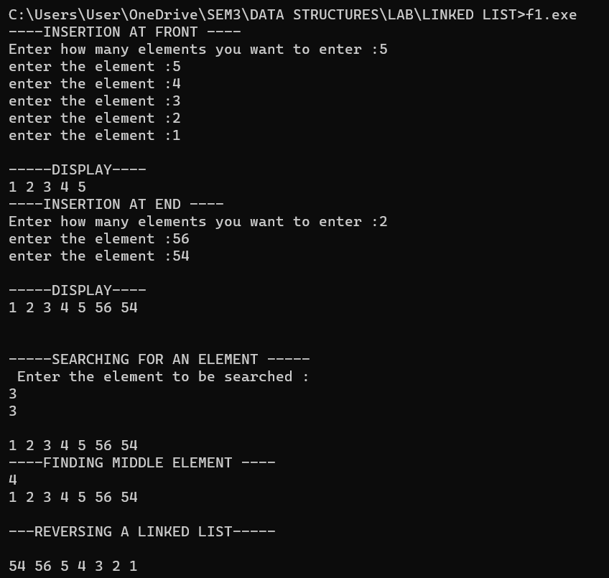

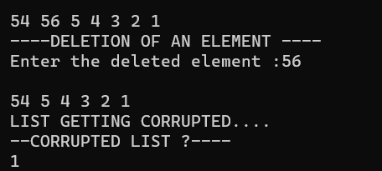

QUESTION 2: Write a program to subtract the given two polynomials
Example:
Poly1: 6x⁷+8x³ +7x²+9,
Poly2: 7x³+6
Resultant Poly: 6x⁷+15x³+ 7x²+15

CODE:
Main.c
#include <stdio.h>
#include <stdlib.h>
#include "polyadt.h"

void main()
{
struct poly *header;
header = (struct poly*)malloc(sizeof(struct poly));
header->next = NULL;
struct poly *header1;
header1 = (struct poly*)malloc(sizeof(struct poly));
header1->next = NULL;
printf("enter the number of terms of P1:");
int n1;
scanf("%d",&n1);
printf("enter the number of terms of P2:");
int n2;
scanf("%d",&n2);
printf("----POLYNOMIAL 1 ----\n");
for (int i=0;i<n1;i++)
{
printf("TERM %d\n",(i+1));
printf("enter the coeff :");
int cf;
scanf("%d",&cf);
printf("enter the exponent :");
int ex;
scanf("%d",&ex);
insert(header,cf,ex);
}

printf("\n----POLYNOMIAL 2 ----\n");
for (int i=0;i<n2;i++)
{
printf("TERM %d\n",(i+1));
printf("enter the coeff :");
int cf;
scanf("%d",&cf);
printf("enter the exponent :");
int ex;
scanf("%d",&ex);
insert(header1,cf,ex);
}

printf("\n---DISPLAYING---\n");
printf("\n----POLYNOMIAL 1 ----\n");
display(header);
printf("\n----POLYNOMIAL 2 ----\n");
display(header1);
printf("\n\n---ADDITION----\n");
add(header,header1);

}
Polyadt.h
#include <stdio.h> #include <stdlib.h>
struct poly
{ int coeff;
int exp;
struct poly *next;
};
void insert(struct poly *h,int c,int e)
{struct poly *ptr;
ptr = h->next;
if (ptr == NULL)
{
struct poly *temp;
temp=(struct poly*)malloc(sizeof(struct poly));
temp->coeff = c;
temp->exp = e;
temp->next = h->next;
h->next = temp;
}
else
{ struct poly *temp;
temp=(struct poly*)malloc(sizeof(struct poly));
temp->coeff = c;
temp->exp = e;
struct poly *prev;
prev = h->next;
while (ptr!=NULL)
{
prev = ptr;
ptr = ptr->next;
}
temp->next = prev->next;
prev->next = temp;
}}
void display(struct poly *h)
{
struct poly *ptr;
ptr = h->next;
while (ptr!=NULL)
{
printf("%d x^%d + ",ptr->coeff,ptr->exp);
ptr=ptr->next;
}
}
void add(struct poly *h1,struct poly *h2)
{
struct poly *p1,*p2;
p1 = h1->next;
p2 = h2->next;
struct poly *sum;
sum=(struct poly*)malloc(sizeof(struct poly));
sum->next = NULL;
while ((p1!=NULL) && (p2!=NULL))
{
if (p1->exp == p2->exp)
{
insert(sum,p1->coeff+p2->coeff,p1->exp);
p1=p1->next;
p2=p2->next;
}
else if (p1->exp > p2->exp)
{
insert(sum,p1->coeff,p1->exp);
p1=p1->next;
}
else if(p1->exp < p2->exp)
{
insert(sum,p2->exp,p2->exp);
p2=p2->next;
}
}

while (p1!=NULL)
{
insert(sum,p1->coeff,p1->exp);
p1=p1->next;
}
while (p2!=NULL)
{
insert(sum,p2->coeff,p2->exp);
p2=p2->next;
}
display(sum);
}

OUTPUT:
